**

**Age**: 55

**Gender**: Male

**Occupation**: Accountant

**Religion**: Scientology

**Site Access**: Micheal accesses the internet mainly through his desktop; however, he does use his phone from time to time.

**Bio**: Micheal is a Chartered Professional Accountant for a busy oil company. A whiz with numbers, he has worked at this company for the past 22 years and is considering retirement soon.

**Goals**: Michael’s sole reason of coming to our website is for gifts for family and friends. He is interested to see if we offer various gift card amounts as his needs fluctuate based on who he is purchasing for.

**Pains**: Michael values efficiency and streamlined experiences. He prefers websites that provide direct access to relevant information, minimizing the need to navigate through excessive promotional content or unnecessary pages. His goal is to complete his online tasks quickly and effectively.

**Scenario #1**: Michael is seeking to purchase a gift card for his niece's upcoming birthday. He understands she is a regular user of eyelash extension services and wishes to support her interest. Accessing our website during his workday, he is interested in exploring the various eyelash extension options and associated costs to determine an appropriate gift card value. As someone unfamiliar with the specifics of eyelash extensions, he is looking for clear, concise information on service types and pricing structures to assist in his decision-making process. Displaying gift cards prominently on the site will assist Michael in accessing our content.

**Scenario #2**: Having purchased a gift card for his niece’s birthday last year, he decides to use our site again for his wife’s birthday. Micheal is on his way home and would like to stop into the shop to get physical copies of the gift certificates to include in a card. He requires an easily accessible address to the shop. Displaying a google maps application that he can link to his phones navigation would make things easy fo Michael.

**Name:** Michelle Allard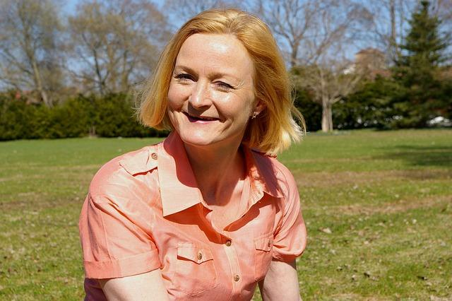

**Age**: 54

**Gender**: Female

**Occupation**: Daycare Worker

**Religion**: Protestant

**Site Access**: Michelle accesses the internet mainly with her iPhone 13 that her husband purchased for her; however, she does use his desktop from time to time as well.

**Bio**: Michelle is a daycare worker, and she enjoys the challenge of being a role model for the children and cares for them deeply. She has worked in numerous positions at various school boards throughout her career as care giver but prefers working with younger children.

**Goals**: Due to Michelles hectic schedule, she is looking for site that will allow her to book appointments online without having to call in everytime.

**Pain Points**: Gabby’s eyesight is not what it used to be, and she has difficulties reading small print. She is unable to navigate many sites today that use small fonts and which pack information into small sections of the screen.

**Scenario #1**: Michelle, prompted by positive recommendations from a friend, is exploring our website to compare our eyelash extension services with her current provider. While generally satisfied with her existing technician, she is seeking a provider who can offer a more reliable and long-lasting result, potentially including a guarantee or warranty on their work. She is interested in how our services and policies might differ from her current experience. Incorporating some sort of guarantee for services rendered in a Policy/FaQ page would help Michelle.

**Scenario #2**: Micheller logs onto the site from an old computer at the daycare, but is having issues reading the content on the screen. She left her glasses in the car and does not have the time to go and get them, as she is watching kids. Incorporating a screen reader with help her access the site.

**Name:** Yvonne Walters

**Age**: 25

**Gender**: Female

**Occupation**: Social Worker

**Religion**: Non-Religious

**Site Access**: Yvonne accesses the internet from her phone. She doesn’t own a desktop but does use her iPad occasionally when she is at home and relaxing on the couch.

**Goals**: Yvonne is looking for an extremely accessible website. She believes all interactions should happen in person.

**Pain Points**: Christina connects to the internet from places that do not have the best internet connection and becomes frustrated with slow-loading, graphics-heavy websites

**Bio**: Yvonne graduated from high school and decided to take a break year and backpack through Eastern Europe while staying in hostiles and meeting new people. Once she got back, she completed a Social Work Diploma from her local community college. She is a very friendly and bubbly woman; she can strike up a conversation with anyone.

**Scenario #1**: Yvonne visits the website to learn about the eyelash technician's philosophy and approach, seeking a relatable and personable professional. The website's design should prioritize warmth, authenticity, and ease of navigation on mobile devices. Incorporating a phone-first approach to the site would is something that would benefit Yvonne.

**Scenario #2**: Yvonne went back to Eastern Europe to see the friends she had met. The week she is to return to Canada, she logs onto our site to book an appointment for when she gets back. The internet connection in her hostile is extremely slow and choppy at the best of times and frequently fails to properly load websites. She requires a website that can function without the need of major bandwidth requirements. Having image alternates when her page fails to load, would assist her in mainting access to the site.

**Name:** Gabby Richardson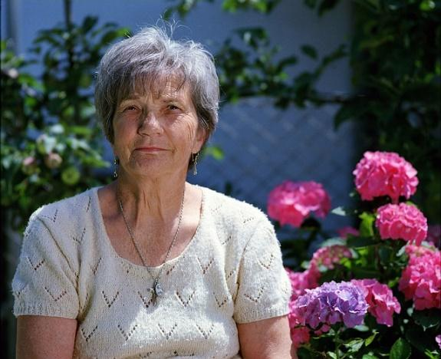

**Age**: 72

**Gender**: Female

**Occupation**: Retired

**Religion**: LDS

**Site Access**: Gabby accesses the internet strictly from s desktop computer. She does not own a mobile phone

**Bio**: Gabby is a retiree and has worked in the hospitality industry for most of her life. She is widowed for 3 years and spends most of her time at the local legion playing cards with other seniors in her area. Gabby is very family oriented and when she is not playing cribbage with her friends she enjoys having her grandkids over for sleepovers. Being a retiree, she is fugal and always looking for things on sale.

**Goals**: Gabby requires an eyelash extension business whose website caters to those with disabilities

**Pains**: Gabby expresses significant concerns regarding online privacy and data security. She is particularly apprehensive about the potential for invasive tracking and the misuse of personal information. This apprehension extends to online payment portals, where she fears falling victim to fraudulent activities.

**Scenario #1**: Gabby accesses our website from her desktop computer and is looking to purchase gift certificates for her daughter’s birthday. With this being the first time she is using our site she is hesitant to give her credit card information out online. Having an SSL certificate displayed prominently as well as a trusted purchasing options would make Gabby feel more comfortable using the site.

**Scenario #2**: Gabby will be attending her daughters wedding next week and has decided that she would surprise her daughter and get the false lashes that she loves so much. With this being her first time getting her lashes done, she is nervous that her eyes will become irritated and that it will affect her eyesight. Having a page that displays common lash myths and having a proper eyecare section will make Gabby less apprehensive.

**

**Age**: 32

**Gender**: Female

**Occupation**: Esthetician

**Religion**: Catholic

**Site Access**: Alex uses her phone for most of her online viewing. Most of the sites she spends time on come from social media links.

**Bio**: Alex has been working as an Esthetician since she completed the course 5 years ago. She enjoys everything beauty and is continuously researching all the latest procedures and products.

**Goals**: Alex is interested in staying current with the latest beauty trends and techniques. She is interested in finding high-quality products and services and potentially collaborating with other beauty professionals.

**Pains**: As it seems like everyone is an eyelash technician these days, Alex gets frustrated with unprofessional or unskilled eyelash technicians. She has difficulties finding trustworthy information and reviews online.

**Scenario** **#1**: Alex comes across our site on her phone while she is looking for eyelash studios in her area. Being in the beauty industry herself, she appreciates websites that display the technicians’ qualifications and work that the technician has completed. She searches through our site to see if our qualifications are up to her standards.

**Scenario #2**: Alex comes back to our site after being pleased with her last experience. This time she is looking at the possibility of exchanging services; she is willing to provide facials to the technician for the application of eyelashes. She comes to the site with the premise of contacting the technician and seeing if they are willing to do this.

**

**Age**: 14

**Gender**: Female

**Occupation**: Student

**Religion**: Non-religious

**Site Access**: Chirstina accesses the internet solely through her mobile phone

**Bio**: Christina is a very outgoing young girl in grade 9. She will be entering high school next year and is always looking for ways to make herself seem older and more mature. Being a grade 9 student, Christina is easily influenced by her peers and is beginning to be more self conscious as she gets older

**Goals**: Find entertaining content related to beauty and fashion as well as, information about becoming an eyelash technician

**Pain Points**: Chistina is color blind and has troubles reading certain font colors

Scenario #1: Christina come to our website considering getting eyelash extension for the first time. She is looking for a welcoming and informative site that showcase the different lash styles and highlighting the transformation they offer through before and after pictures. She is looking for clear and precise pricing information, along with testimonials from other clients.

Scenario #2: Christina's positive experience with eyelash extensions has sparked a career interest in becoming an eyelash technician. She comes back to our site actively seeking information on our website to determine the necessary qualifications and explore the possibility of pursuing this path while still in high school.

Pic #1: https://pixabay.com/photos/portrait-man-businessman-5519817/

Pic #2: https://pixabay.com/photos/woman-middle-aged-mischievous-happy-797394/

Pic #3: https://pixabay.com/photos/girl-model-portrait-smile-smiling-1867092/

Pic #4: https://pixabay.com/photos/granny-woman-senior-elder-elderly-1280445/

Pic #5: <https://pixabay.com/photos/woman-portrait-model-knitwear-2150881/>

Pic #6: https://pixabay.com/photos/girl-teenage-girl-eyes-beauty-7172289/